Lab 2: Layered Architecture Design – Microservice

Activity Practice 1: Defining Layers and Responsibilities

1. Four-tier architecture in the Microservice system
Floor | Floor name | Responsibility | Ingredient
1 | Presentation Layer | Receive requests from clients, authenticate JWT tokens, and route requests to the appropriate services. | API Gateway, React Frontend
2 | Business Logic Layer | Each service handles its own business logic and operates independently. | AuthService, ProductService, OrderService, CartService, VoucherService, ProfileService, CategoryService, BrandService
3 | Persistence Layer | Perform CRUD operations and query data through the Repository. | AuthRepository, ProductRepository, OrderRepository, CartRepository, VoucherRepository, ProfileRepository, CategoryRepository, BrandRepository
4 | Data Layer | Data storage: Each service has its own separate database. | DB_Auth, DB_Product, DB_Order, DB_Cart, DB_Voucher, DB_Profile, DB_Category, DB_Brand

Principles of Microservice Architecture
- Each service operates independently.
- Each service has its own database.
- Services communicate via API Gateway or internal APIs.
- Each service can be deployed, scaled, and maintained separately.

2. Processing flow when the user views product details

Step 1 – Client sends a request
GET /products/{id}
Users submit requests to view product details from the React Frontend interface.

Step 2 – Presentation Layer
The API Gateway receives and processes requests:
- Verify JWT Token
- Check access permissions
- Route requests to Product Service
Client
↓
API Gateway

Step 3 – Business Logic Layer
Product Services handle business logic:
- Check if the product exists.
- Check stock availability
- Call Category Service to get the category name.
- Call Brand Service to get brand information.
ProductService
↓
CategoryService
BrandService

Step 4 – Persistence Layer
ProductRepository performs the data query:
SELECT * FROM products WHERE id = ?

Step 5 – Data Layer
The Product Service's MySQL database returns product data to the Repository.
DB_Product
↑
ProductRepository

Step 6 – Return data to the Client
- ProductService aggregates data.
- API Gateway encapsulates JSON Response
- The frontend displays data to the user.
ProductService
↑
API Gateway
↑
Client

Activity Practice 2: Component Identification

1. List of Services and Components
Service | Controller Layer | Service Layer | Repository Layer | Database
Auth Service | AuthController | AuthService | UserRepository | DB_Auth
Profile Service | ProfileController | ProfileService | ProfileRepository | DB_Profile
Product Service | ProductController | ProductService | ProductRepository | DB_Product
Category Service | CategoryController | CategoryService | CategoryRepository | DB_Category
Brand Service | Fire Controller | BrandService | BrandRepository | DB_Brand
Cart Service | CartController | CartService | CartRepository | DB_Cart
Order Service | OrderController | OrderService | OrderRepository | DB_Order
Voucher Service | VoucherController | VoucherService | VoucherRepository | DB_Voucher

2. Interface between floors

Presentation Layer gọi Business Logic Layer
ProductService.getProductDetails(String productId) : Product

Business Logic Layer gọi Persistence Layer
ProductRepository.findById(String productId) : ProductEntity

The Business Logic Layer calls other services.
CategoryService.getCategoryById(String categoryId) : Category
BrandService.getBrandById(String brandId) : Brand

Activity Practice 3: Component Diagram (PlantUML)
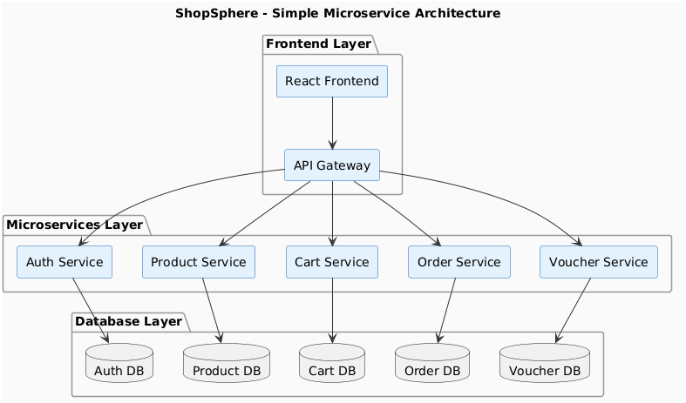

Architectural explanation
Ingredient | Role
React Frontend | The user interface sends all requests through the API Gateway.
API Gateway | Single gateway, JWT authentication, routing to the correct service.
8 Microservices | Each service is independent and handles a separate business process.
8 separate databases | Each service has its own MySQL database; they are not shared.

